FLIGHT DELAY PREDICTION

1.INTRODUCTION :
Delay is one of the most remembered performance indicators of any transportation system.Notably, commercial aviation players understand delay as the period by which a flight is lateor postponed. Thus, a delay may be represented by the difference between scheduled and realtimes of departure or arrival of a plane. Country regulator authorities have a multitude of indicators related to tolerance thresholds for flight delays. Indeed, flight delay is an essen_xfffe_tial subject in the context of air transportation systems. In 2013, 36% of flights delayed by more than five minutes Europe 31.1oflights delayed by more than 15 minutes in the
United States, and 16.3% of flights were canceled or suffered delays greater than 30 minutes inBrazil. This indicates how relevant this indicator is and how it effects no matter the scale of airline meshes. Flight delays have negative impacts, mainly economic, for passengers, airlines, and airports. Given the uncertainty of their occurrence, passengers usually plan to travel many hourearlier for their appointments, increasing their trip costs, to ensure their arrival on time On the other hand, airlines suffer penalties, fines and additional operation costs, such as crewand aircrafts retentions in airports Furthermore, from the sustainability point ofview, delays may also cause environmental damage by increasing fuel consumption Delays also jeopardize airlines marketing strategies, since carriers rpley on customers’ loyalty to support their frequent flyer programs and the consumer’s choice is also affected by
reliable performance. There is a identified relationship between levels of delays

1.1 OVERVIEW
Cost to airlines Edit In the United States, the Federal Aviation Administration estimates that flight delays cost airlines $22 billion yearly. Airlines are forced to pay federal authorities when they hold planes on the tarmac for more than three hours for domestic flights or more than four hours for international flights.Cost to passengers
This article may require cleanup to meet Wikipedia's quality standards. The specific problem is Flight delays are an inconvenience to passengers. A delayed flight can be costly to passengers by making them late to their personal scheduled events and commitments. A passenger who is delayed on a multiplane trip could miss a connecting flight. Anger, frustration and even Air rage can occur in delayed pass CompensationEdit Flights from the US to the EU on EU airlines are covered by Regulation 261/2004. This requires airlines to pay compensation of up to €600 if the flight is delayed more than three hours on arrival time Flights to the US from the EU are covered by the regulation regardless of the airline. This means a US airline can still be required to pay passengers compensation under Regulation For example, a flight departing London to New York on American Airlines would be covered by the regulation, but the return journey on the same airline would not. The New York to London flight on an EU carrier, such as British Airways or Virgin woul d be covered.

1.2 PURPOSE
Delays can be induced by different sources and affect airports, airlines,enroute airspace or resemble of them. For analysis purposes, one may assume a simplified system where only one of these actors or any combination of them is considered. It should be noted that any scope ofapplication can be combined with any problem .Some work focused on airports to predict delays for all departs considered all airlines anden route airspace indifferently. Airports are also the focus when the objective is to investigate their efficiency based on delays of all carriers. On the other hand, only airlines are considered when comparing the performance of two airlines under the same conditions An resemble of airport and enroute airspace were studied to understand the relationship between congestion and delays. Others considered airports and airlines as well to evaluate capacity problems and airlines decisions. There are many possibilities to ensemble scopes. This becomes important when studying the dynamics of air transportation systems, mainly when targeting root delay

2. LITERATURE SURVEY
2.1 Existing problems
Delays can be induced by different sources and affect airports, airlines, enroute airspace or an ensemble of them. For analysis purposes, one may assume a simplified system where only one of these actors or any combination of them is considered. It should be noted that any scope of application.Some work focused on airports to predict delays for all departs considered all airlines and enroute airspace indifferently . Airports are also the focus when the objective is to investigate their efficiency based on delays of all carriers . On the other hand, only airlinesare considered when comparing the performance of two airlines under the same conditions
An ensemble of airport and en route airspace were studied to understand the relationship between congestion and delays . Others considered airports and airlines as well to evaluatecapacity problems and airlines decisions . There are many possibilities to ensemble scopes.This becomes important when studying the dynamics of air transportation systems, mainly when targeting root delay We are all too familiar with the literacy of statistics that demonstrate without question that action is needed on behalf of air travelers and the aviation sector of the national economy. One of the most compelling statistics is that last year almost 2 million flights operated by large air carriers did not land on time because they were delayed, cancelled, or diverted. That is almost 27 percent of the operations reported by these carriers.Imagine any other business telling its customers that 27 percent of the time the service they paid for is not available as advertised. TheAdministration has made commitments at the highest levels to address this problem. When Secretary Peters met with President Bush last September, he said, “We’ve got a problem, we understand there’s a problem, and we’re going to address the problem.”I think we all agree that the air traveler deserves a better approach. Last year, according to the American Customer Satisfaction Index, the satisfaction level with the airline industry overall fell to its lowest level in 7 years. The statistics we gather monthly at DOT confirm deteriorating service levels. In 2007, there was a sharp rise in the number of complaints received by the Department – 13,168 complaints, which is over 58% more than the 8,325 complaints received in 2006. Complaints are continuing at a high rate in 2008 – the Department received 3,152 complaints during the first quarter of this year. For us, the objective is not to parcel out the blame, but to get to the root of the problem – congestion. Consumer satisfaction would be vastly improved if flights simply arrived on schedule. The growing lack of reliability in air travel these days is one of the most significant impacts of congestion.

2.2 PROPOSED SOlUTION
In this notebook, I develop a model aimed at predicting flight delays at takeoff. The purpose is not to obtain the bestpossible prediction but rather to emphasize on the various steps needed to build such a model. Along this path, I then put in evidence some basic but important concepts. Among then, I comment on the importance of the separation of the dataset during the training stage and how cross validation helps in determing accurate model parameters. I show how to build linear and polynomial models for univariate or multivariate regressionsand also, I give some insight on the reason why regularisation helps us in developing models that generalize well. From a technical point of view, the main aspects of python covered throughout the notebook are:

visualization: matplolib, seaborn, basemapdata manipulation: pandas, numpy modeling: sklearn, scipyclass definition: regression, figuresDuring the EDA, I intended to create good quality figures from which the information would be easily accessible at a first glance. An important aspect of the data scientist job consists in divulgating its findings to people who do not necessarily have knowledge in the technical aspects data scientists master. Graphics are surely the most powerful tool to achieve that goal, and mastering visualization techniques thus seems important.Also, as soon as an action is repeated a few times, I tend to write classes or functions and eventually embedded them in loops. Doing so is sometimes longer than a simple copy-paste edit process but, on the one hand, this improves the readibility of the code and most importantly, this reduces the number In the current notebook, I defined classes in the modeling part in order to perform regressions. I also defined a class to wrap the making of figures. This allows to create stylish figures, by tuning the matplotlib parameters, that can be subsequently reused thanks to that template. I feel that this could be useful to create nice looking graphics and then use them extensively once you are satisfied with the tuning. Moreover, this helps to keep some homogeneity in your plots.
3 .THEORTICAL ANALYSIS
3.1 Block Diagram

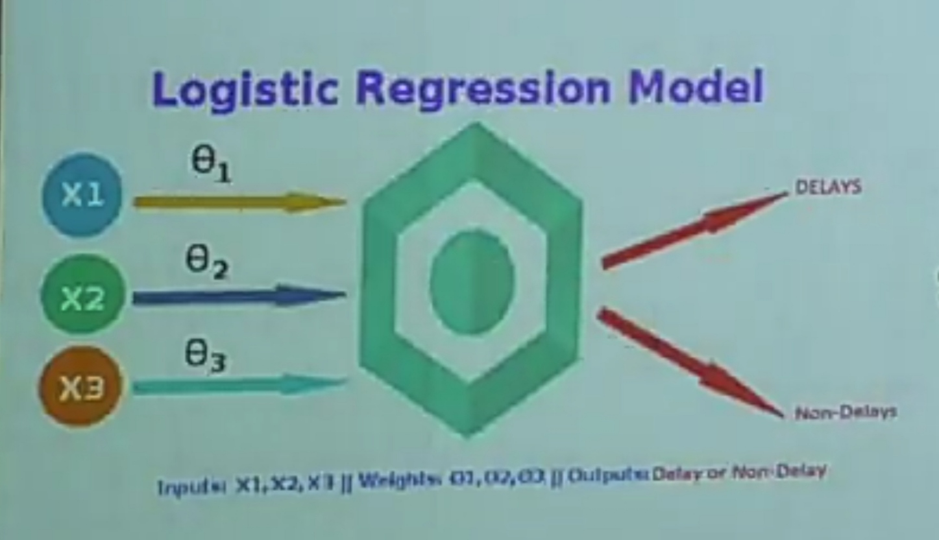

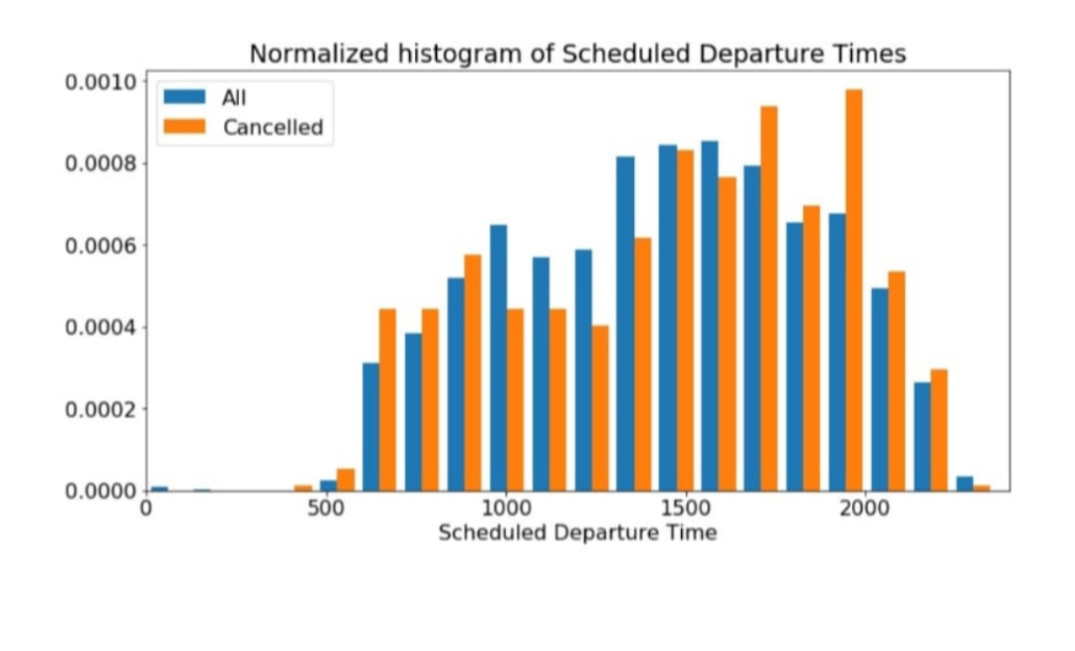
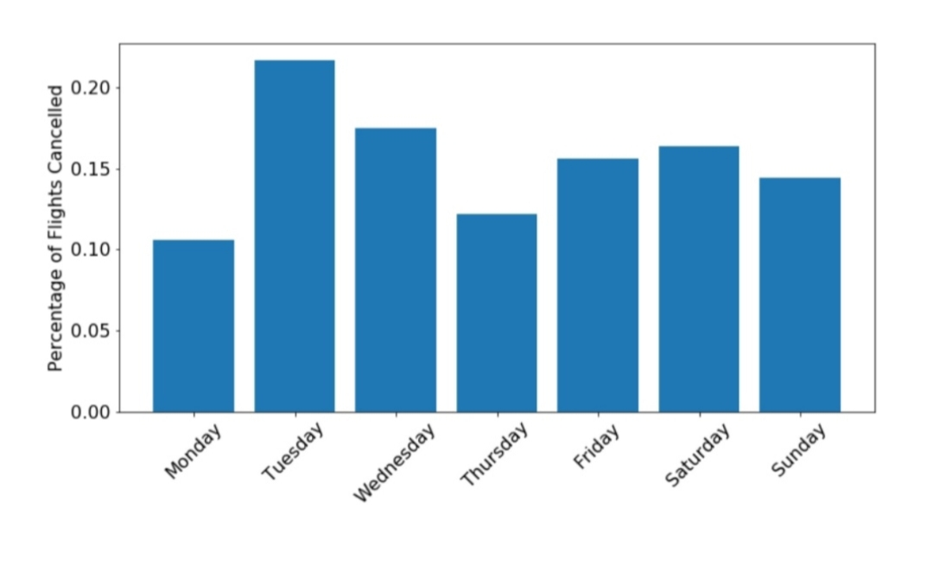
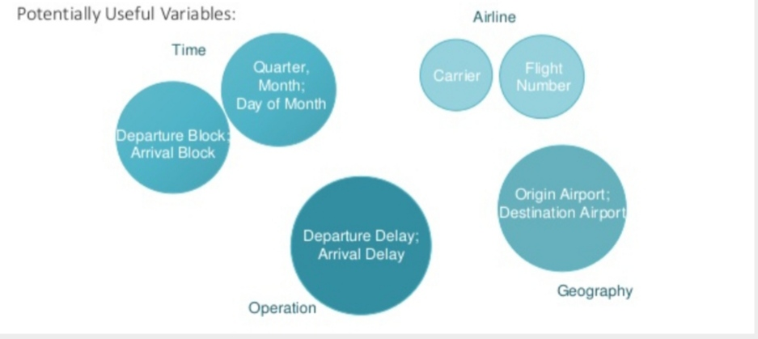
3.2 Hardware/software Design

4.EXPERIMENTAL INVESTIGATIONS

To ensure that we are correctly using the set of algorithmsfor solving this problem, we chose to explore some of theparameters of each of the methods. For example, RandomForest has a number of interesting parameters: maximumdepth of the tree, number of trees in the forest, maximumnumber of features to 8consider when looking for the bestsplit, etc. We plotted F1score against each of these param_xfffe_eters to ensure we are using an optimal configuration forRandom Forest, some of which are shown below. In eachof the following plots, ”trn X” is the training data F1score on X, where X=0 is the non-delayed class, X=1 is the delayed class, and X=A is the aggregate/total F1-score of thetwo classes. There is a similar nomenclature for ”tst X”,where the data is the test data.Here we see that the max depth of the tree must be larger than 40 to ensure that the F1score is sufficiently high.Here we see that the optimal minimum samples per leaf value is 3.Here are the lessons we learned from exploring parametersof Random Forest, Gaussian Naivebayes, and Logistic Regression:
Random Forest’s maximum tree depth should belarger than 40, which is close to the number of.fea_xfffe_tures used (37). Random Forest’s min samples required to be a leaf node should be 3. Too small and the leaf node doesn’thave enough children, to large and each node has too many children to compare. Random Forest’s max features should remain unconstrained, the algorithm has a search feature that allow sit to estimate how many features it should consider forany given leaf. Gaussian NaivBayes’s prior should be skewed 9 to1, to help compensate for the dataset class imbalance

5. FLOW CHART

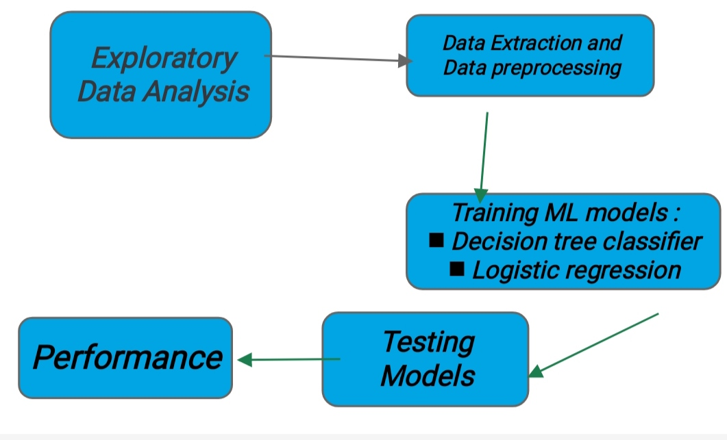
.
6.RESULT
Because of the class imbalance we observe in our dataset, we cannot use accuracy as a metric. Instead, we focus on precision, recall, and most importantly the F1score, which is the harmonic mean between precision and recall. In thefollowing table we provide all of these metrics for delayed,not-delayed, and total, across each of the algorithms we used, as well as the baseline predictor (predicting all flightsas not-delayed). Random Forest achieves the best total F1score of 0.82. We used K-fold cross validation for final results reporting, using 5 folds (we have a dataset largeenough to allow it).Here is the ROC curve for the delayed class. Coincidentally, the AUC value for the delayed class is 0.81Since flight delays cause economic consequences to passengers and airlines, recognizing themthrough prediction may improve marketing decisions. Due to that, several forecast modelshave been built over the last twenty years. These models have sought to understand how delays propagate through the network of flights or airports, to predict root delay in the system or to comprehend the cancellation process. Beyond these three points of view for treating the flightdelay prediction problem, models could also differ by their scope of application, data issue sand methods.The number of papers has increased in the late 2000 since 87.5% of the works had been published between 2007 and 2017. Regarding only the documents considered in this analysis, displays the number of publications grouped by methods. It can be observed asignificant growth in machine learning and data mining in the last decade. A depicts the complete timeline of papers, showing most cited authors per period and categoriesof methods. Pondering the way for tackling the delay problem, it was seen a balance between
the number of papers that consider delay propagation and root delay, while few works deemedsole the cancellation analysis. indicates the foremost journals in which flightdelay material was published, it is possible to observe the leading authors in the fielddisplays the main collaboration graph from authors in our systematic review

7.ADVANTAGES AND DISADVANTAGES
No. There are no federal laws requiring airlines to provide passengers with money or other compensation when their flights are delayed. Each airline has its own policies about what it will do for delayed passengers. If your flight is experiencing a long delay, ask airline staff if they will pay for meals or a hotel room. While some airlines offer these amenities to passengers, others do not provide any amenities to stranded passengers.How do I find out how long my flight will be delayed Airlines are required to provide passengers with information about a change in the status of the flight if the flight is scheduled to depart within 7 days. Airlines are required to give these status updates 30 minutes after the airline becomes aware of a status change. The flight status information must, at a minimum, be provided on the airline's website and via the airline's telephone reservation system.
Also, when a flight is delayed for 30 minutes or more, the airline must update all flight status displays and other sources of flight information at U.S. airports that are under the airline's control within 30 minutes after the airline becomes aware of the problem.Why are flights sometimes delayed for several hours. It is sometimes difficult for an airline to estimate how long a delay will be during its early stages. When a flight delay unexpectedly becomes longer and longer, this is called a “creeping delay.” During “creeping delays,” unexpected developments can cause a delay to be longer than anticipated. For example, weather that was supposed to improve can instead become worse, or a mechanical problem can turn out to be more complex than the airline originally thought.If my flight is delayed, can I switch to a different flight Possibly. If your flight is delayed, you can try to arrange another flight on your airline. It is sometimes easier to make such arrangements by calling the airline, through the airline’s website or mobile application, or via social media. Before you decide to switch flights, check if the airline will charge you a fee and a higher fare for changing your reservation. If you find a flight with an available seat on another airline, you can ask the first airline to transfer your ticket to the alternative airline – this practice could save you money by avoiding a fare increase. However, there are no federal regulations requiring airlines to put you on another airline’s flight or reimburse you if you purchase a ticket on another airline. Also, keep in mind that changing flights and airlines becomes more difficult and time consuming if you have checked bags.My flight is significantly delayed I entitled to a refundIt depends. In some situations, you may be entitled to a refund, including a refund for all optional fees associated with the purchase of your ticket such as baggage fees, seat upgrades, etc. DOT has not specifically defined “significant delay.” Whether you are entitled to a refund depends on a lot of factors such as the length of the delay, the length of the flight, and your particular circumstances. DOT determines whether you are entitled to a refund on a case by case basis. Flight CancellationsWhat happens when my flight is cancelled. If your flight is cancelled, most airlines will rebook you for free on their next flight to your destination as long as the flight has available seats. If your flight is cancelled and you choose to cancel your trip as a result, you are entitled to a refund for the unused transportation even for non refundable tickets. You are also entitled to a refund for any bag fee that you paid, and any extras you may have purchased, such as a seatassignment. If the airline offers you a voucher for future travel instead of a refund, you should ask the airline about any restrictions that may apply, such as blackout and expiration dates,advanced booking requirements, and limits on number of seats.If my flight is cancelled, can my airline put me on another airline’s flight Yes. While airlines are not required to put you on another airline’s flight, they can and sometimes do, so it does not hurt to politely ask your airline if it will transfer your ticket to another airline that has a flight with available seats. Ask the airline or check online to see if another carrier has open seats and then ask if the first airline will transfer your ticket to that carrier. Remember, however, that airlines are not required to do this. Also, be aware that finding available seats on another airline’s flight may be difficult, especially during holidays and other peak travel times.
8.APPLICATIONS
FlightAware is a bit of a Swiss army knife when it comes to flight tracking apps. With it, you can track the real time flight status and location of any commercial flight worldwide which comes in handy when your flight is delayed
9.CONCLUSION
Flight delays are an important subject in the literature due to their economic and environmentalimpacts. They may increase costs to customers and operational costs to airlines. Apart fromoutcomes directly related to passengers, delay prediction is crucial during the decision-makingprocess for every player in the air transportation system.In this context, researchers created flight delay models for delayprediction over the lastyears, and this work contributes with an analysis of these models from a Data Science perspec_xfffe_tive. We developed a taxonomy scheme and classified models in respect of detailed compo_xfffe_nents.Mainly, the taxonomy includes domain and Data Science branches. The former branch categorizes the problem (flight delay prediction) and the scope. The last branch groups methodsand data handling. It was observed that the flight delay prediction is classified into two maincategories, such as delay propagation and root delay and cancellation. Besides, the scope de_xfffe_termines one of the three specific extents: airline, airport, enroute airspace anensemble of them.Additionally,considerng Data Science branch, we aim at the datum, by categorizing data sources, dimensions that can be used in the models, and data management techniques topreprocess data and improve prediction models efficiency. We also studied and divided the main methods into five categories: statistical analysis, probabilistic models, network representation,operations research, and machine learning. Those categories have been grouped as their use onspecific forecast models for flight delays.Besides the taxonomic scheme, we also presented a timeline with all articles to spot trendsand relationships involving the main elements in the taxonomy. In the light of the domainproblem classification, this timeline showed a dominance of delaypropagation and root delayover cancellation analysis. Researchers used to focus on statistical analysis and operationalresearch approaches in the past. However, the data volume grows, we noticed the use of machine learning and data management is increasing significantly. This clearly characterizes Data Science trend.Researchers from airlines, airports, and academia will require a combination of skills of both domain specialists and data scientists to enable knowledge discovery from flight Big Data.

10.FUTURE SCOPE
We were able to use publicly available data, intuition, andmachine learning algorithms to predict whether a flight willbe delayed by more than 15 minutes with an F1 score of 82%, using Random Forests or Neural Network. Those algorithms perform well because they are able to capturethe underlying complexity of our problem, provided thatwe can control for overfit. We have not been able tofind a better prediction result in the literature for similar projects. The three major sources of improvement we implemented were: aggregation of several weather sources to
get complete and accurate data, careful tuning of models meta-parameters, feature engineering to capture time de_xfffe_pendence. Our future work includes four different direc_xfffe_tions:•Generate new features that capture of the co-dependence between a flight’s delay and the nextflights delay (as of now, we only account for firstorder time dependencies, but the interactions in realityare more complex).• Use additional features (twitter data, finer resolution terror data, etc.) to account for factors that contribute to delays but are invisible by our algorithms as of nowdue to the absence of proxy variables.• Improve our neural network. Due to lack of time, wecould not explore as much as we wanted to neural network approach, but results already were promising using only out of the box algorithms. Use more of the already available data to improve our delay classes

11 BIBILOGRAPHY
Administration, Federal Aviation. Passenger boarding (enplanement) and all-cargo data for u.s. airports - previous years, 2008. URL https:
//www.faa.gov/airports/planning_
capacity/passenger_allcargo_stats/
passenger/previous_years/.
Administration, Federal Aviation. Faa registry n-number
inquiry, 2016. URL http://registry.faa.gov/
aircraftinquiry/NNum_Inquiry.aspx.
ASA. 2009 data expo. asa statistics computing and graphics, 2009. URL http://stat-computing.org/
dataexpo/2009/.Bandyopadhyay, R. and Guerrero, R. Predicting airline de_xfffe_lays. Technical report, Computer Science Department,
CS 229, Stanford University, Stanford, CA, 2012.
Database, Global Terrorism. Global terrorism database,
2016. URL https://www.start.umd.edu/
gtd/.
E.R.Mueller and G.B.Chatterji. Analysis of aircraft arrivaland departure delay characteristics. In AIAA’s AircraftTechnology, Integration, and Operations (ATIO) 2002
Technical, NASA, Moffet Field, CA, US

